

**AHSANULLAH UNIVERSITY OF SCIENCE AND TECHNOLOGY**

**Course No:** CSE 4126

**Course Title:** Distributed Database System

**Project Name:** Mobile Banking System

**Name:** MD. Yeasir Arafat

**ID:** 16.02.04.093

**Section:** B

**Group:** B2

**Introduction:**

**Mobile banking** is a service provided by a **bank** or other **financial** institution that allows its customers to conduct **financial** transactions remotely using a **mobile** device such as a smartphone or tablet. **Mobile banking** is dependent on the availability of an internet or data connection to the **mobile** device.In this project I used **Oracle 10g** as a **distributed database management System** and the language is **PL/SQL**. There are three types of **Actors** in this system. They are:

1. Main
2. Agent
3. Client

**Main:**

They are **Shareholders** of this **Mobile Bank**. They can **Cash In** to their own account using their **Phone number** and **Password**. And they can also **send money** to one of an **Agent**. If phone number and password **is incorrect**, money **won’t be transferred**. They can also see **their profile** and their **transaction history**. And they can also see the **Profit** of their Company.

**Agent:**

Agents are **middleman** between **Shareholders** and **Clients**. Agent can **Cash In** to a Client’s Account and no charge will be needed for this. And also Agent could **Send Money** to another **Agent** or **Client**. To do this transaction, **5 taka** will be charged from **Agent’s Account**. And this money will be added to the **profit** table. Agent can also **Send Money** to **Main** and no charge needed for this transaction. Agent can also see their **Profile** and **Transaction History** of their Account.

**Client:**

Clients can **Cash Out** from their account to an **Agent’s Account**. It takes **20 taka charge** per **one thousand** taka Cash OUT. And charged money will be added to the **profit table**. Client can also **Send Money** to another **Client** or an **Agent**, **5 taka** will be charged from **Clients Account** for this transaction. They can also see their **Profile** and **transaction History**.

**Database Tables(site_1)**

**Table 01: Client (Fragment 1)**

|  |  |  |
| --- | --- | --- |
| **Field** | **Type** | **Constraint** |
| cid | Varchar2(15) | P.K (Not Null) |
| cName | Varchar2(30) | Not Null |
| cPass | Varchar2(30) | Not Null |
| cAmount | integer | Not Null |
| cAddress | Varchar(30) | Not Null |

**Table 02: cHistory**

|  |  |  |
| --- | --- | --- |
| **Field** | **Type** | **Constraint** |
| ch_id | number | P.K (Not Null) A.I |
| cid | Varchar2(15) | Not Null |
| ch_date | Varchar2(20) | Not Null |
| To_whom | Varchar2(15) | Not Null |
| ch_amount | integer | Not Null |
| ch_type | Varchar2(15) | Not Null |

**Table 03: Profit**

|  |  |  |
| --- | --- | --- |
| **Field** | **Type** | **Constraint** |
| pid | number | P.K (Not Null) A.I |
| pFrom | Varchar2(15) | Not Null |
| pAmount | Integer | Not Null |
| pDate | Varchar2(20) | Not Null |

**Database Tables(site_2)**

**Table 01: Client (Fragment 2)**

|  |  |  |
| --- | --- | --- |
| **Field** | **Type** | **Constraint** |
| cid | Varchar2(15) | P.K (Not Null) |
| cName | Varchar2(30) | Not Null |
| cPass | Varchar2(30) | Not Null |
| cAmount | integer | Not Null |
| cAddress | Varchar(30) | Not Null |

**Table 02: Agent**

|  |  |  |
| --- | --- | --- |
| **Field** | **Type** | **Constraint** |
| aid | Varchar2(15) | P.K (Not Null) |
| aName | Varchar2(30) | Not Null |
| aPass | Varchar2(30) | Not Null |
| aAmount | integer | Not Null |
| aAddress | Varchar(30) | Not Null |

**Table 03: aHistory**

|  |  |  |
| --- | --- | --- |
| **Field** | **Type** | **Constraint** |
| ah_id | number | P.K (Not Null) A.I |
| aid | Varchar2(15) | F.K(agent.aid) Not Null |
| ah_date | Varchar2(20) | Not Null |
| To_whom | Varchar2(15) | Not Null |
| ah_amount | integer | Not Null |
| ah_type | Varchar2(15) | Not Null |

**Table 04: Main**

|  |  |  |
| --- | --- | --- |
| **Field** | **Type** | **Constraint** |
| m_id | Varchar2(15) | P.K (Not Null) |
| mName | Varchar2(30) | Not Null |
| mPass | Varchar2(30) | Not Null |
| mAmount | integer | Not Null |
| mAddress | Varchar(30) | Not Null |

**Table 05: mHistory**

|  |  |  |
| --- | --- | --- |
| **Field** | **Type** | **Constraint** |
| mh_id | number | P.K (Not Null) A.I |
| m_id | Varchar2(15) | F.K(main.m_id) Not Null |
| mh_date | Varchar2(20) | Not Null |
| To_whom | Varchar2(15) | Not Null |
| mh_amount | integer | Not Null |
| mh_type | Varchar2(15) | Not Null |

**Functions of this Project:**

**Client**

**SendMoney (** ‘User_id’,‘Password’, Amount, ‘SendTo’ **)**

**CashOut ( ‘**User_id’,‘Password’, Amount, ‘AgentID’ **)**

**cHistory (** ‘User_id’, ‘Password’ **)**

**profileC (** ‘User_id’, ‘Password’ **)**

**registerNewClient (** ‘User_id’, ‘Name’, ‘Password’, ‘ConPass’,‘Address’ **)**

**Agent**

**SendMoney (** ‘User_id’,‘Password’, Amount, ‘SendTo’ **)**

**CashIn ( ‘**User_id’,‘Password’, Amount, ‘ClientID’ **)**

**aHistory (** ‘User_id’, ‘Password’ **)**

**profileA (** ‘User_id’, ‘Password’ **)**

**Main**

**SendMoneyM (** ‘User_id’,‘Password’, Amount, ‘SendTo’ **)**

**CashInM ( ‘**User_id’,‘Password’, Amount **)**

**mHistory (** ‘User_id’, ‘Password’ **)**

**profileM (** ‘User_id’, ‘Password’ **)**

**Screenshots:**

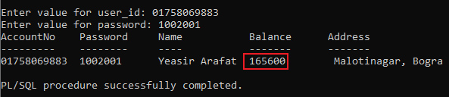Profile of a Main Account:

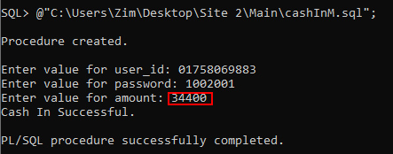Cash In to a Main Account:

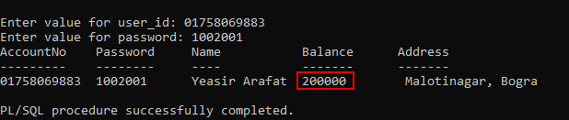After Cash In New Balance of a Main Account:

Profile of an Agent’s Account:

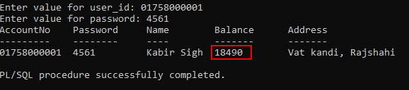

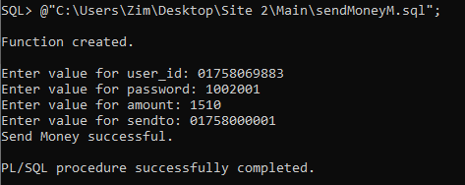Send Money from Main to Agent’s Account:

After Send Money Main’s new balance:

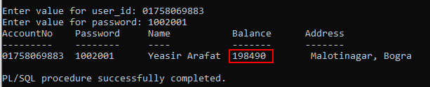

After Send Money Agent’s new balance: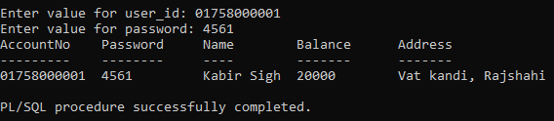

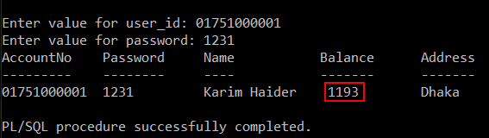Profile of a Client’s Account:

Send Money from Agent to Client’s Account: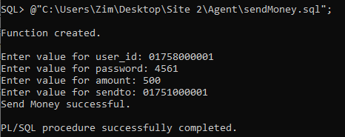

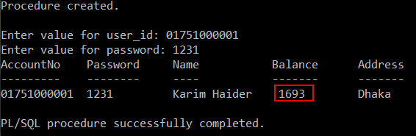Client’s New Balance:

Agent’s New Balance ( Charged 5 tk for Send Money ) 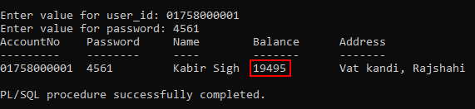:

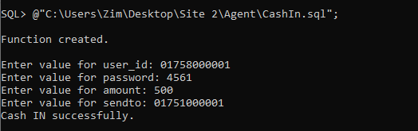Cash In to Client’s Account from an Agent:

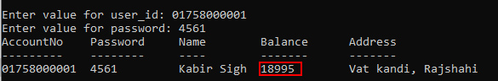Agent’s New Balance:

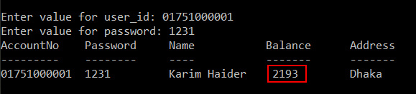Client’s New Balance:

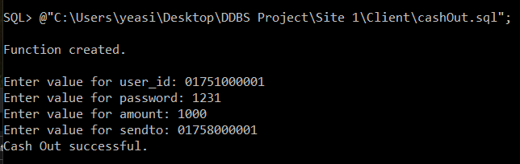Cash Out from Clients Account:

New Balance of Client’s Account ( 20tk charge apply per thousand tk transaction ):

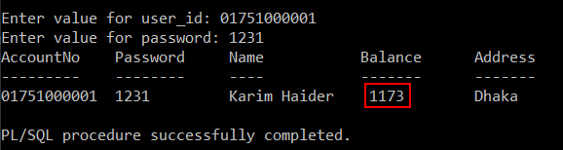

New Balance of Agent’s Account: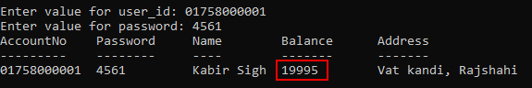

Send Money from Client to Agent’s Account: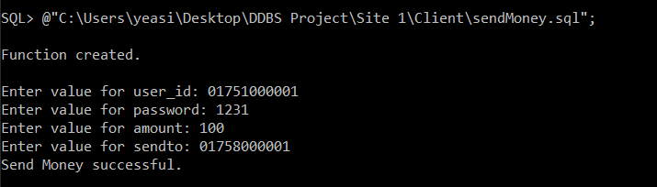

Client’s New Balance ( Charged 5 tk for Send Money ):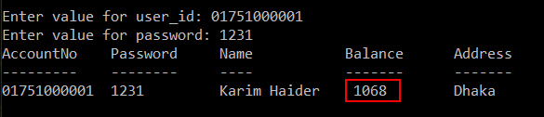

Agent’s New Balance: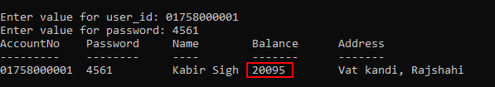

Register new Client: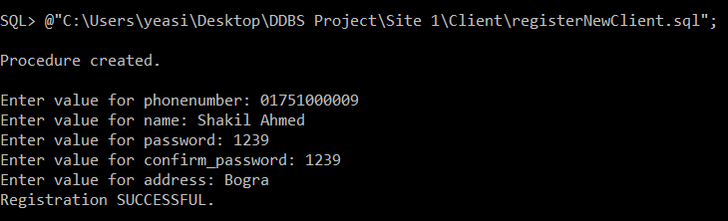

New Client Profile: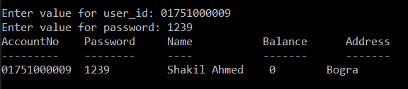

Send Money From Agent to Main’s Account: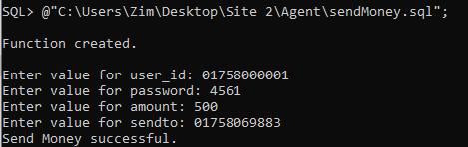

New Balance of Agent’s Account (No charge needed for Send Money to Main):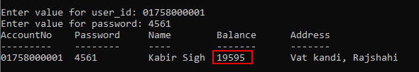

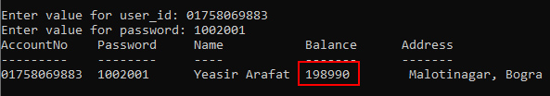New Balance of Main’s Account:

Client History ( Descending Order ) :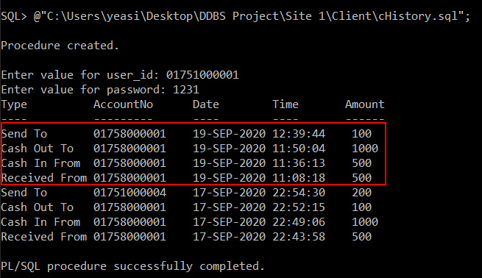

Agent History ( Descending Order ):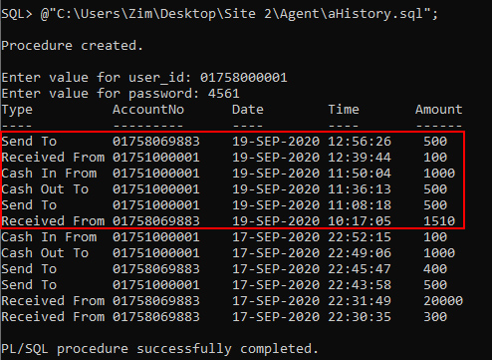

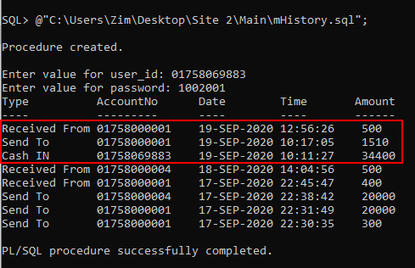Main Admin’s History ( Descending Order ):

Profit details ( Only accessible by Main users):

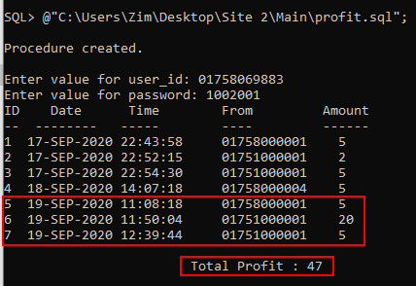

**Conclusion:**

Mobile Banking services makes it convenient to access the banking services at any time as per 24*7 conditions. Mobile banking is a self service empowerment to the customers and thus reduces the dependency of bank's staff to facilitate the services. And it was a very pleasant journey to make such a database and design it to fulfil all the requirements of a MobileBanking System with the help of Oracle 10g software.